**Power BI Assignment 5**

1. Explain DAX.

* Data Analysis Expressions (DAX) is a programming language that is used throughout Microsoft Power BI for creating calculated columns, measures, and custom tables. It is a collection of functions, operators, and constants that can be used in a formula, or expression, to calculate and return one or more values. You can use DAX to solve a number of calculations and data analysis problems, which can help you create new information from data that is already in your model.

1. Explain datasets, reports, and dashboards and how they relate to each other?

**Dataset types :**

* Power BI datasets represent a source of data that's ready for reporting and visualization. You can create Power BI datasets in the following ways:
* Connect to an existing data model that isn't hosted in Power BI.
* Upload a Power BI Desktop file that contains a model.
* Upload an Excel workbook that contains one or more Excel tables and/or a workbook data model, or upload a comma-separated values (CSV) file.
* Use the Power BI service to create a [push dataset](https://learn.microsoft.com/en-us/rest/api/power-bi).
* Use the Power BI service to create a [streaming or hybrid streaming dataset](https://learn.microsoft.com/en-us/power-bi/connect-data/service-real-time-streaming).

**Reports :**

* Pages : Can be created in one or more pages
* Data sources : Reports are created from a single dataset
* Visualization : Reports are not concentrated on the visualization part of the data rather it looks to create summary pages.
* Available in Power BI Desktop : Reports can be built and viewed in Power BI Desktop.
* Filters and Slicers : In reports, we can use many different ways to filter, highlight, and slice.
* User Interactivity : **Reports** are more focused on being able to visualize and apply transformations to a single dataset.
* Favourite : Can set multiple reports as favourites.
* Q&A Feature : Yes, provided you have edit permissions for the report and underlying dataset.
* Alerts : We can’t create Alerts in Reports.
* Subscribe : Yes. Can subscribe to a report page.
* See underlying dataset tables and fields : While in **Reports** you can see a dataset under the **Data** tab in Power BI Desktop.

**Dashboards :**

* Pages : Dashboards are created on only one page
* Data sources : Dashboards are created from multiple datasets or reports.
* Visualization : Dashboards always concentrate on building insights into the data by using graphs, attractive visuals, charts, etc.
* Available in Power BI Desktop : Dashboards can not be created in Power BI Desktop
* Filters and Slicers : You cant add Slicers and Filters as Dashboards are limited to a single page.
* User Interactivity : Dashboards allow a user to pin visuals from different reports and datasets onto a single canvas, making it simple to group what’s essential to the user.
* Favourite : Yes. Can set multiple dashboards as favourites.
* Q&A Feature : Yes
* Alerts : In dashboards, alerts to emails are created, when specific condition or criteria is met or limit crossed.
* Subscribe : Yes. Can subscribe to a dashboard.
* See underlying dataset tables and fields : In dashboards, you can’t see the underlying dataset tables but can export data.

1. How reports can be created in power BI, explain two ways with Navigation of each.

**1st way :**

* **Step 1: Select your data :**
* From inside the Power BI home screen, click **Get Data**.
* Choose from the list or click **More**.
* You can use various data sources for Power BI reports including Excel and CSV files, online services like Facebook and Adobe, or a database such as Oracle.

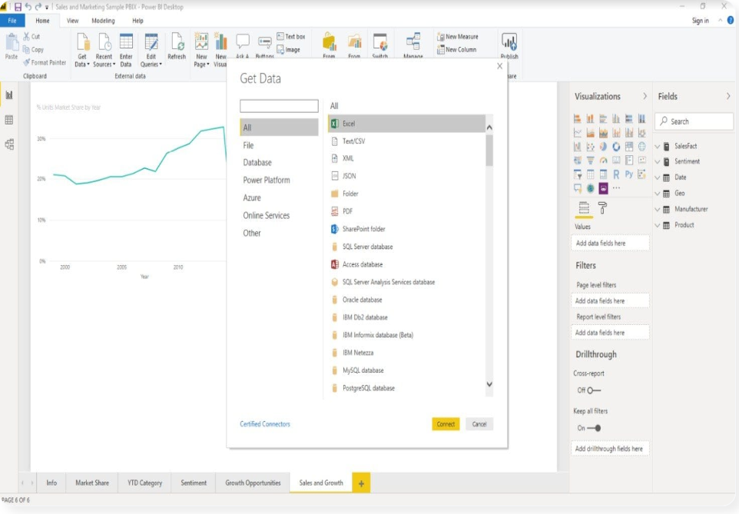

* **Step 2 : Create a chart in Power BI :**
* Two menus appear: **Visualizations** and **Fields**. A visualization (also known simply as a **visual**) is the chart, graph, or diagram that presents insights from your dataset. **Fields** are the tables and folders containing the data you want to present.
* For my first visualization, I will create a simple **Time Series Chart** by clicking on **Sales Fact**and selecting**Sum of Revenues**from the dropdown menu.
* You can move this, or any other KPI, by dragging and dropping it to **Values** under the visualizations side menu.
* In addition, you must add the dates under **Axis**.
* Go to **Date**and then, via the dropdown menu, move the date field to**Axis.**
* You can now resize and move the chart.

**2nd Way :**

* **How to connect to SQL server using Power BI Desktop**

**-** Please click on the Get Data hyperlink.

**-** If you are on the visualization page, click the Get Data option under the Home tab and select the SQL Server, as shown below. Or select More options.

**-** We are selecting More options to show you the following window. Use this window to select your desired Data source. Here, we are discussing how to Connect Power BI to SQL Server. So, let me choose the SQL Server Database Option.

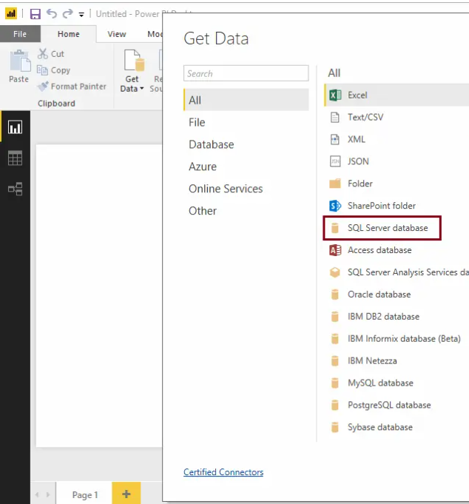

### **Connection Options:**

The following is the list of available fields to fill in to connect the desktop to the Database.

* Server: Please provide the Instance name. If you [installed Server](https://www.tutorialgateway.org/install-sql-server/) with the default instance, the instance name is the computer name or localhost.
* Database: This is optional. If you want to use a custom query, then it is required.
* Data Connectivity Mode: Please select whether you want to import or Direct query.

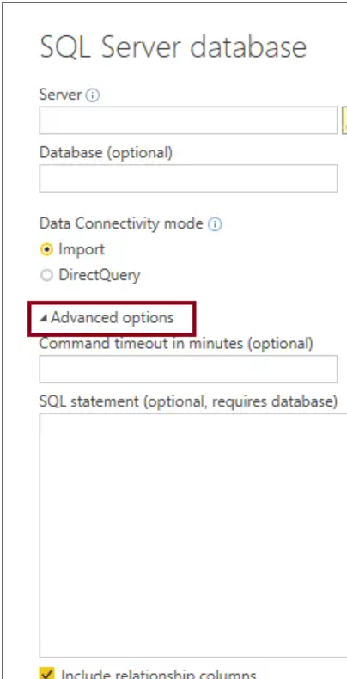

1. How to connect to data in Power BI? How to use the content pack to connect to google analytics? Mention the steps.

**Connect to data :**

* With Power BI Desktop, you can connect to many different types of data. These sources include basic data sources, such as a Microsoft Excel file. You can connect to online services that contain all sorts of data, such as Salesforce, Microsoft Dynamics, Azure Blob Storage, and many more.
* To connect to data, from the **Home** ribbon select **Get data**.

* The **Get Data** window appears. You can choose from the many different data sources to which Power BI Desktop can connect. In this quick start, use the Excel workbook that you downloaded in [Prerequisites](https://learn.microsoft.com/en-us/power-bi/connect-data/desktop-quickstart-connect-to-data#prerequisites).

1. How to import Local files in Power BI? Mention the Steps.

**Below are steps by which we import data into PowerBi.**

* In Power BI, click Get Data in the lower left screen.
* Under Import or Connect to Data > Files, click Get.
* Click Local File.
* Choose which file to upload and click Open.
* Click Upload under Upload your Excel file to Power BI.
* The message “Your file has been uploaded” should appear.

# **Use the Google Analytics connector for Power BI Desktop:**

You can connect to Google Analytics data using the **Google Analytics** connector. To connect, follow these steps:

1. In Power BI Desktop, select Get Data from the Home ribbon tab.
2. In the Get Data window, select Online Services from the categories in the left pane.
3. Select Google Analytics from the selections in the right pane.
4. At the bottom of the window, select Connect.

1. In Power BI visualization, what are Reading View and Editing view?

**Reading View :**

* There are two modes for interacting with reports in the Power BI service: Editing view and Reading view. If you are a business user, then you are more likely to use Reading view to consume reports created by others. Editing view is used by report designers, who create the reports and share them with you. Reading view is your way to explore and interact with reports created by colleagues.
* Even in Reading view, the content isn't static. You can dig in, looking for trends, insights, and other business intelligence. Slice and dice the content, and even ask it questions using your own words. Or, sit back and let your data discover interesting insights for you; send you alerts when data changes, and email reports to you on a schedule you set. All your data, any time, in the cloud or on-premises, from any device.

**Editing view :**

Below are some of functionalities available in editing view :

* Creating, editing, renaming, sharing, and deleting reports.
* Adding, renaming, rearranging, and deleting report pages.
* Formatting reports.
* Adding visualizations, text boxes, shapes, and buttons to a report.
* Adding visual-level, page-level, and report-level filters and setting visual interactions.
* Creating refresh schedules.
* Using Q&A functionality to create visuals in reports.
* Showing data used to create the visualization.
* Setting up drillthrough.
* Duplicating a report page.
* [Using report settings](https://learn.microsoft.com/en-us/power-bi/create-reports/power-bi-report-settings) to control your readers' interactions with reports.
* A Power BI Pro or Premium Per User (PPU) license is required to edit reports created by others and to share your reports with others. If you don't have a Pro or Premium Per User (PPU) license, you can still create reports, but you can't [share them](https://learn.microsoft.com/en-us/power-bi/collaborate-share/service-share-reports).